Welcome!
Date
Name
Spouse
Address
City
State Zip _________
Email

Please Contact By
❑ Card  Phone  Visit

Telephone Best Time to Call
Home ______________
Work ______________

Guest: First Time Second Time
Are you a church member: yes no
Church
City, State

Circle Appropriate Age/Grade Group(s)
Preschool: Ages: B-1 2-3 4-5
Children: Grades: K 1 2 3 4 5 6
Youth: Grades: 7 8 9 10 11 12
Adults: Ages:18-29 30s 40s 50s 60s+

How did you learn about our church?
Newspaper Friend Yellow Pages Mail
Other

I am a guest of:

New in the Community? Yes No
Names & ages of children at home

Weekly Service & Activity Schedule
December 1, 2013
9:45 a.m. Sunday School
11:00 a.m. Morning Worship

6:00 p.m. Evening Service

Week of December 2 – 7

Wednesday, 6:30 p.m. Youth Activities
Wednesday, 6:45 p.m. Adult Prayer & Bible Study
Wednesday, 7:30 p.m. Praise Team Rehearsal
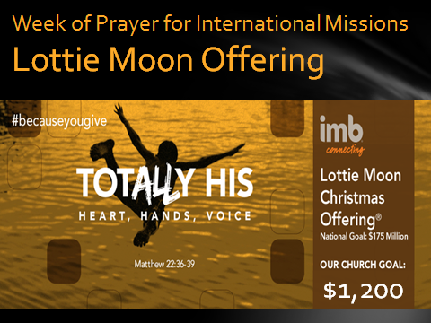

Upcoming Events

December
1-8 Wk of Prayer for International Missions (Lottie Moon)
8 Business Meeting
12 Senior Adult Fellowship – 10 am
22 Lord’s Supper
25 Christmas
31 New year’s Eve Watch Night

Knobbs Springs Baptist Church

“Teacher, which is the
greatest commandment in the law?”

Jesus replied:
“’Love the Lord your God with
all your heart and with all your soul
and with all your mind.’
This is
the first and greatest commandment.
And the second is like it:
‘Love your neighbor as yourself.’

Matthew 22: 36 - 39

December 1, 2013

Church Information:
KnobbsSpringsBC.com KnobbsSpringsBaptist@gmail.com
1662 CR 305, McDade, Texas 78650 512-273-2743
Brother Dwight Reagan 512-247-6448
Kimberly Tabor, Office Manager 512-698-2804

